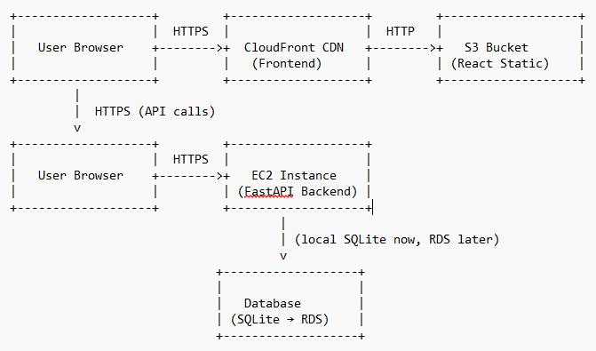

**Frontend:**

* React app is built and deployed to S3.
* CloudFront serves the static site globally with caching and HTTPS.

**Backend:**

* FastAPI runs in a Docker container on an EC2 instance.
* API is exposed via EC2’s public IP or (ideally) behind an Application Load Balancer for scalability.

**Database:**

* Currently SQLite on EC2.
* Future: Managed PostgreSQL (RDS) for scalability and reliability.